**S3:**

Can upload 5 TB as max.

If uploading more than 5 GB, must use **"multi-part upload"**

Naming Convention:

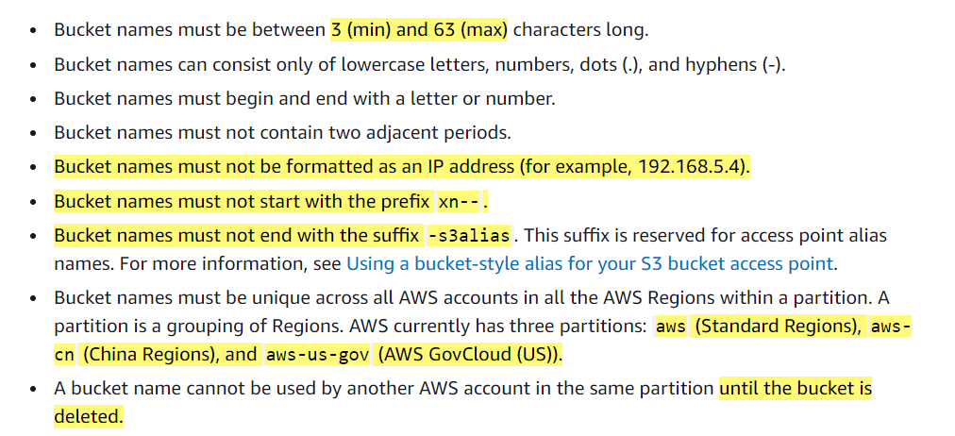

Security:

**User Based:** IAM policies

**Resource Based:** Bucket policies, Object ACLs, Bucket ACLs

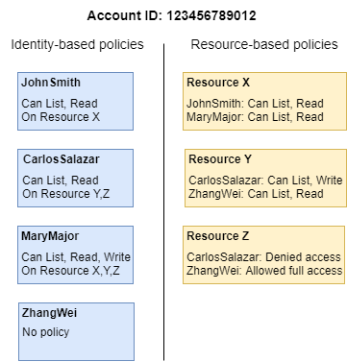

ACLs Enabled vs Bucket Policy:

Either Give permission to individual new objects thru ACLs enabled or given to all objects in a bucket thru bucket policy.

Bucket Policy:

Principal: 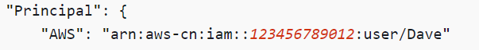

Versioning:

Adding Objects in Version Suspended Bucket:

Storage Classes:



